**DAY 3**

**K.Bhanu teja**

**192111320**

**1.Recruitment System**

**Use Case Diagram**

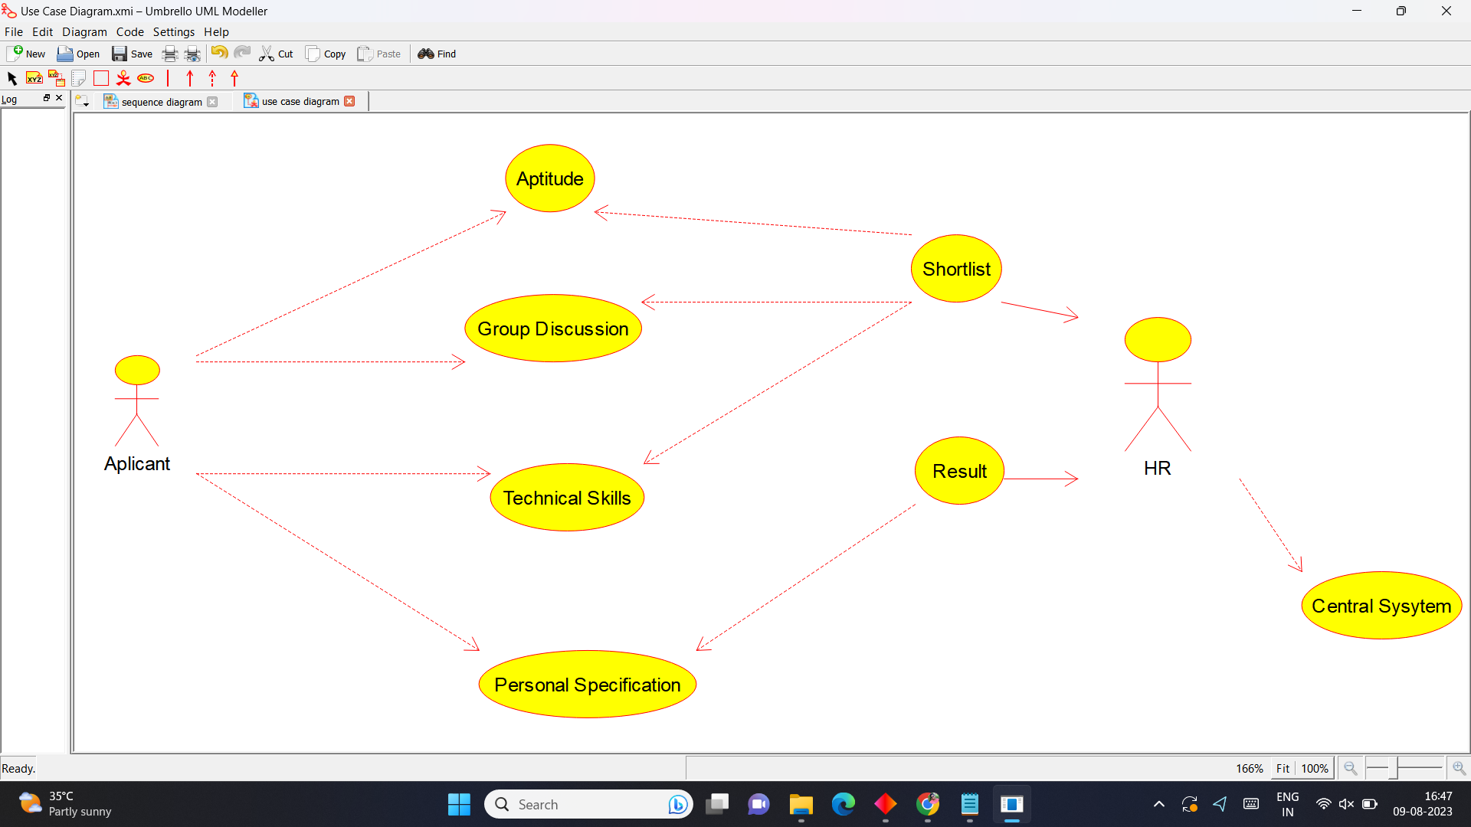

**Class Diagram**

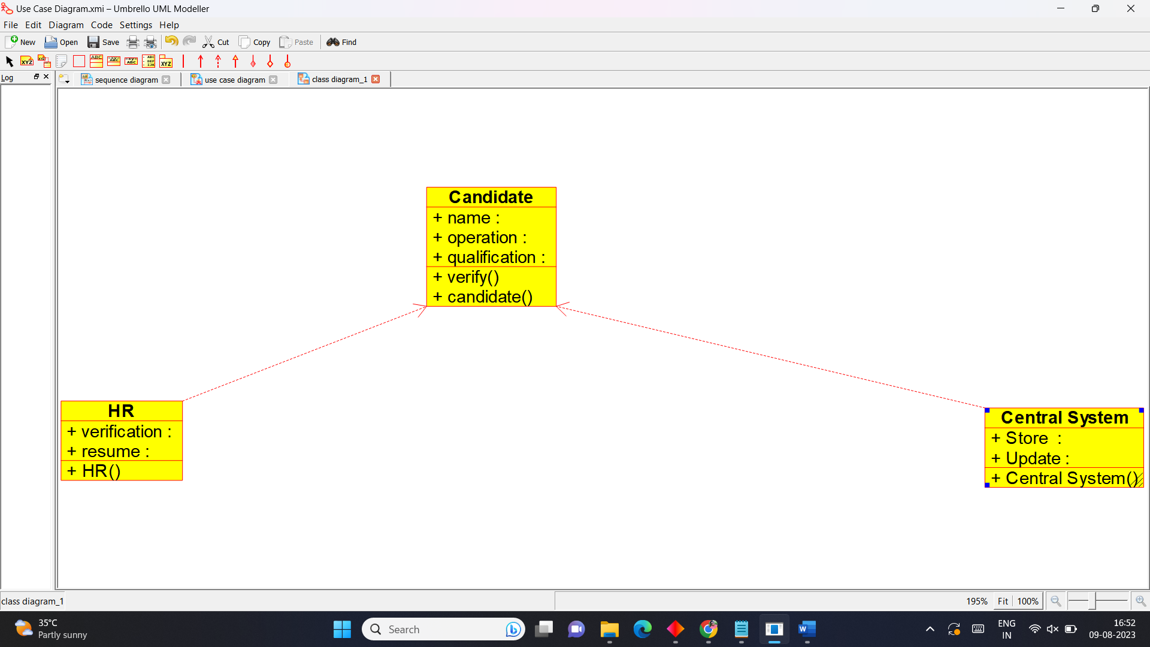

**Activity Diagram**

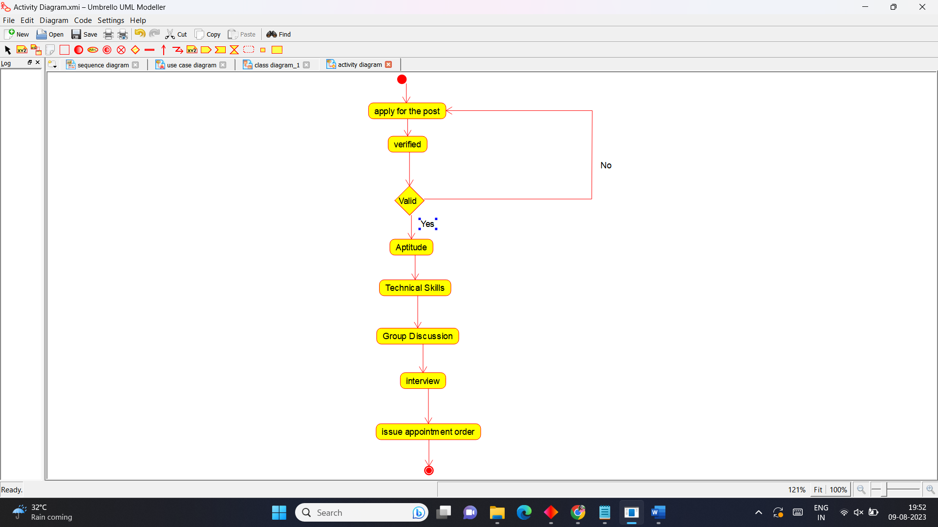

**State Chart Diagram**

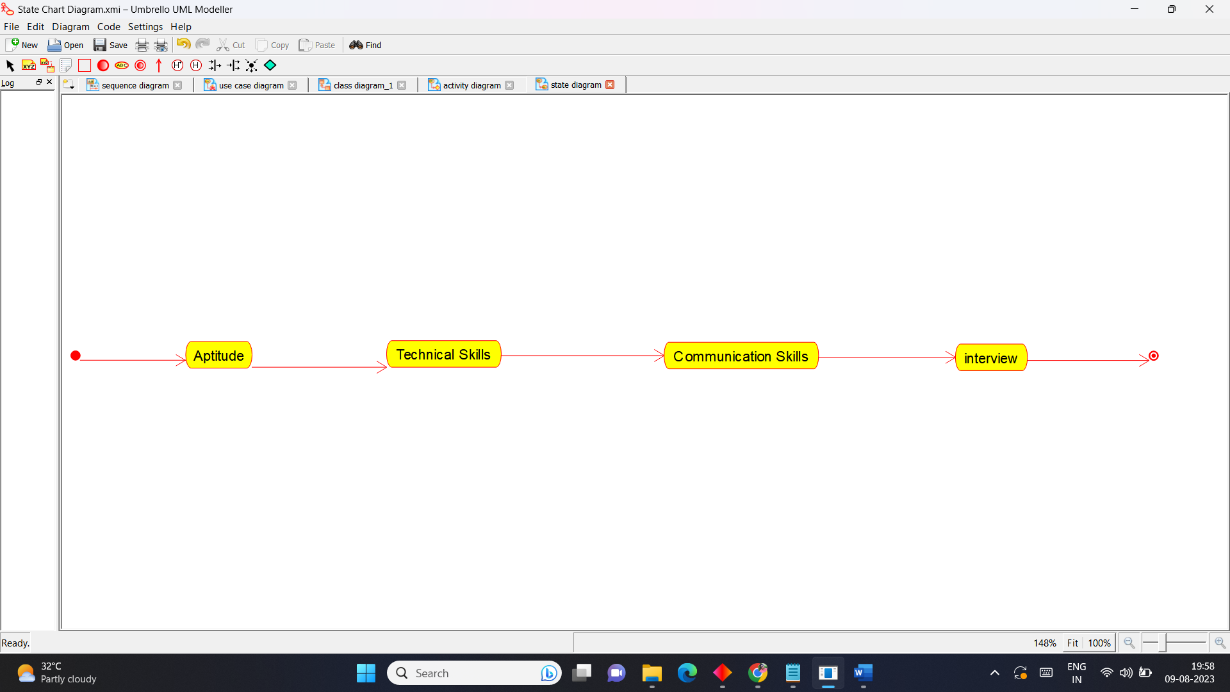

**Sequence Diagram**

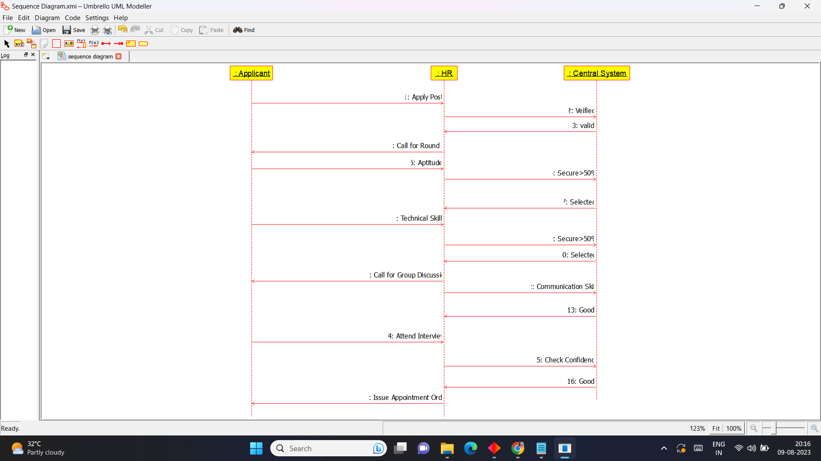

**Package diagram**

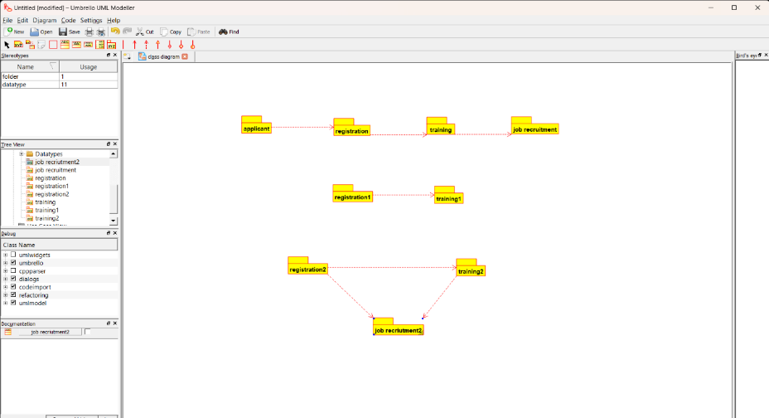

**Deployment Diagram**

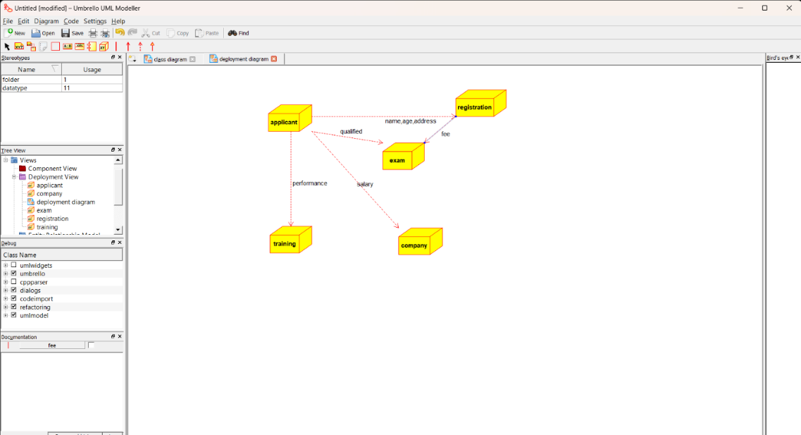

**2.Blood Bank Registration System**

**Use Case Diagram**

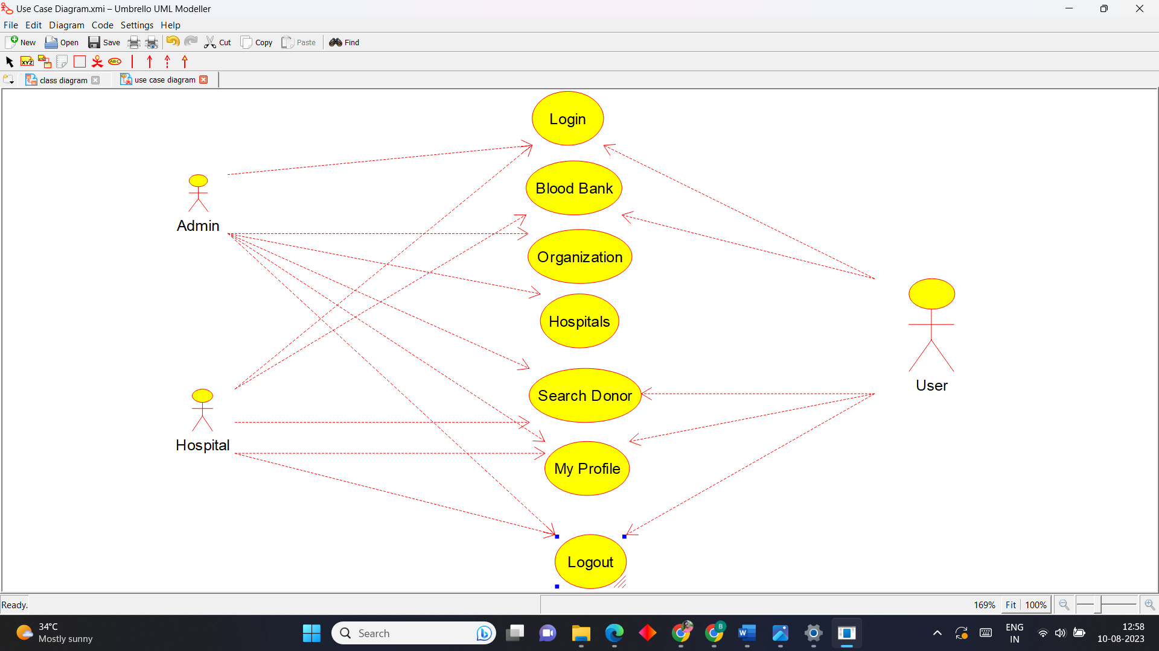

**Activity Diagram**

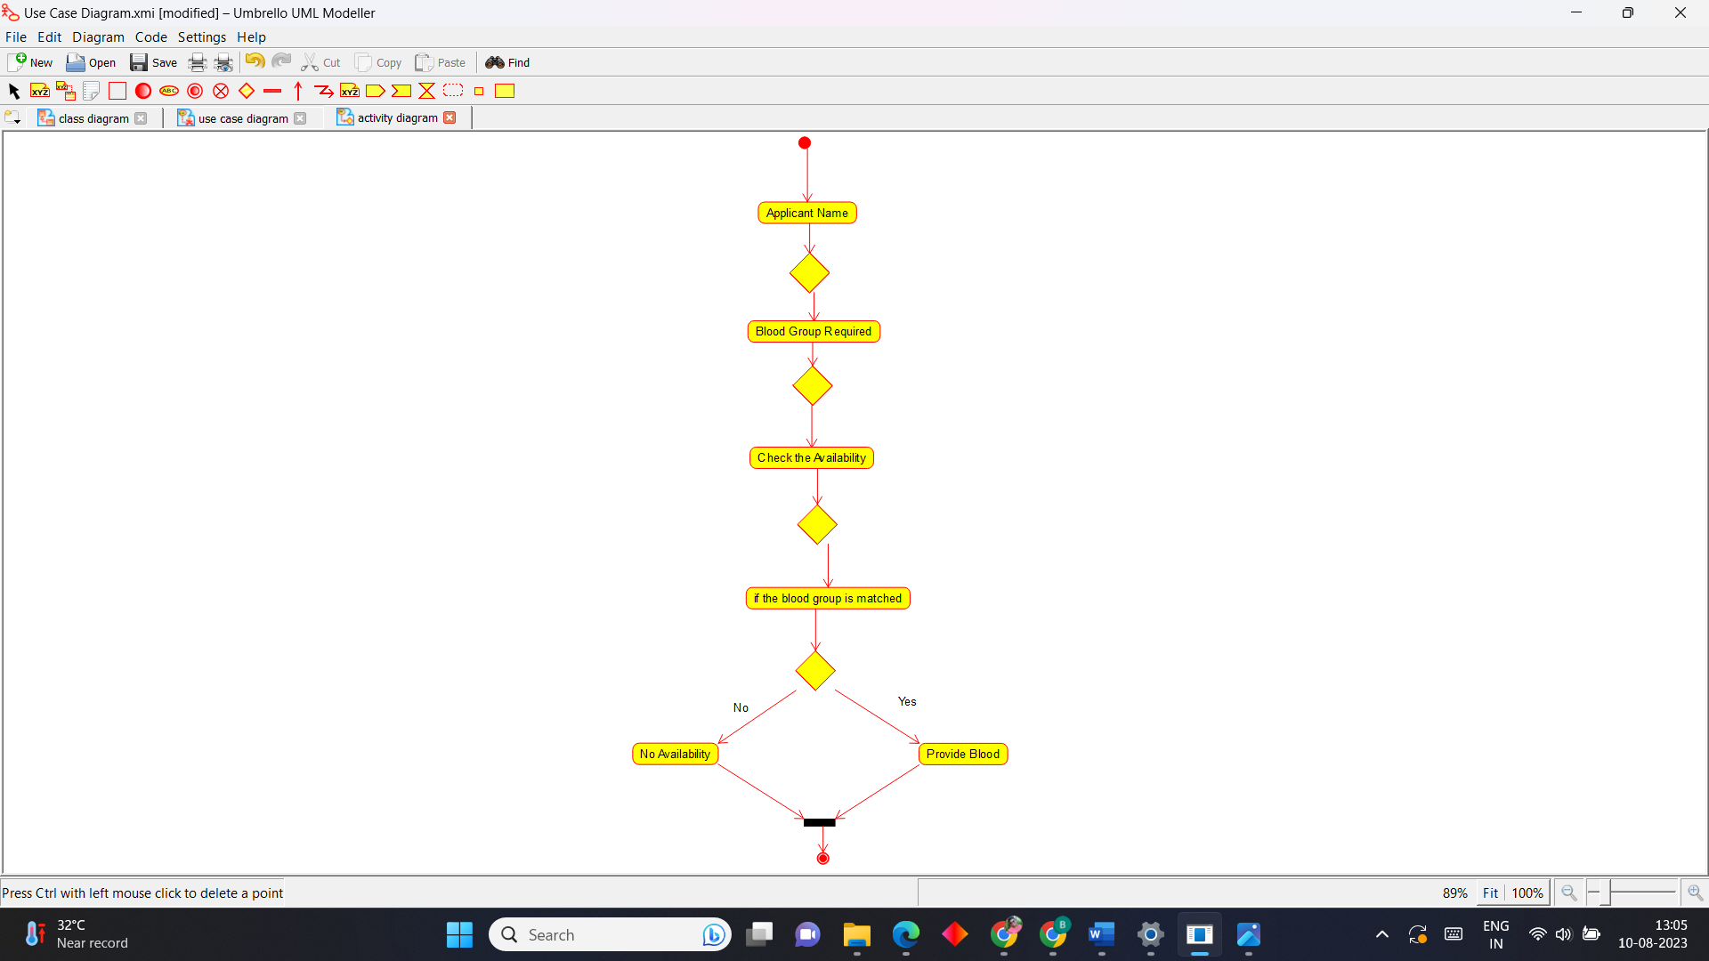

**Sequence Diagram**



**colloboration Diagram**

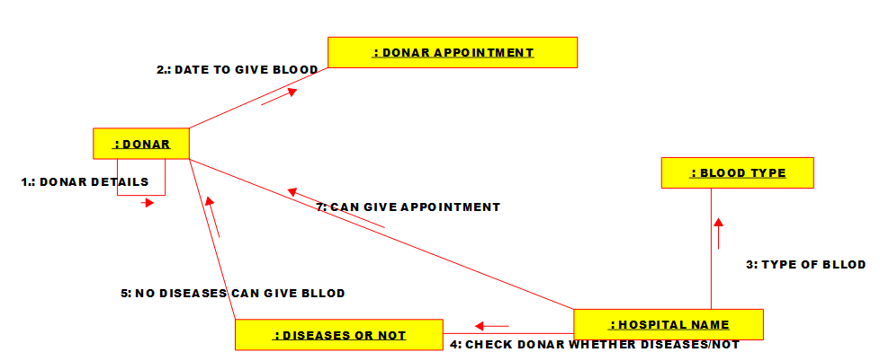

**Statechart Diagram**

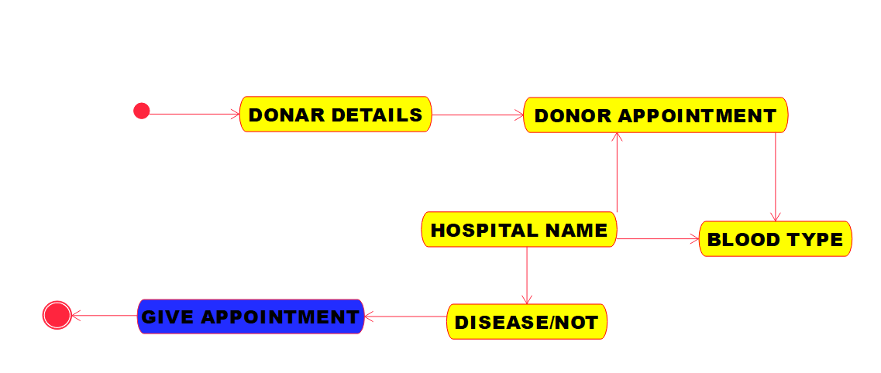

**3.Food Order System**

**Use Case Diagram**

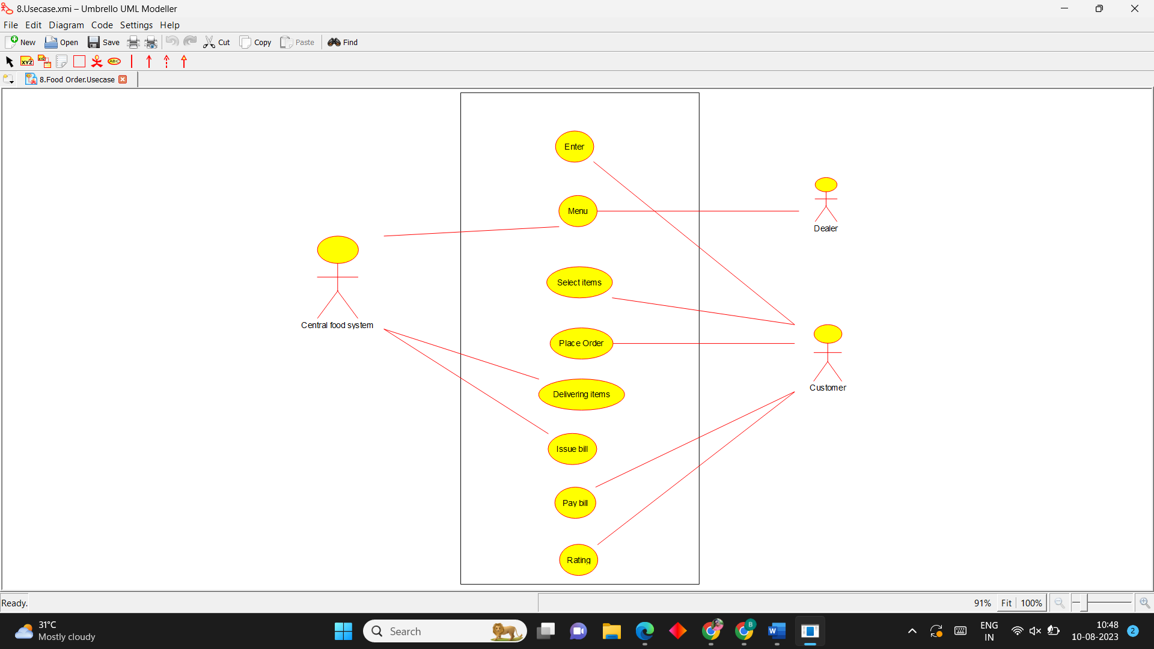

**Activity Diagram**

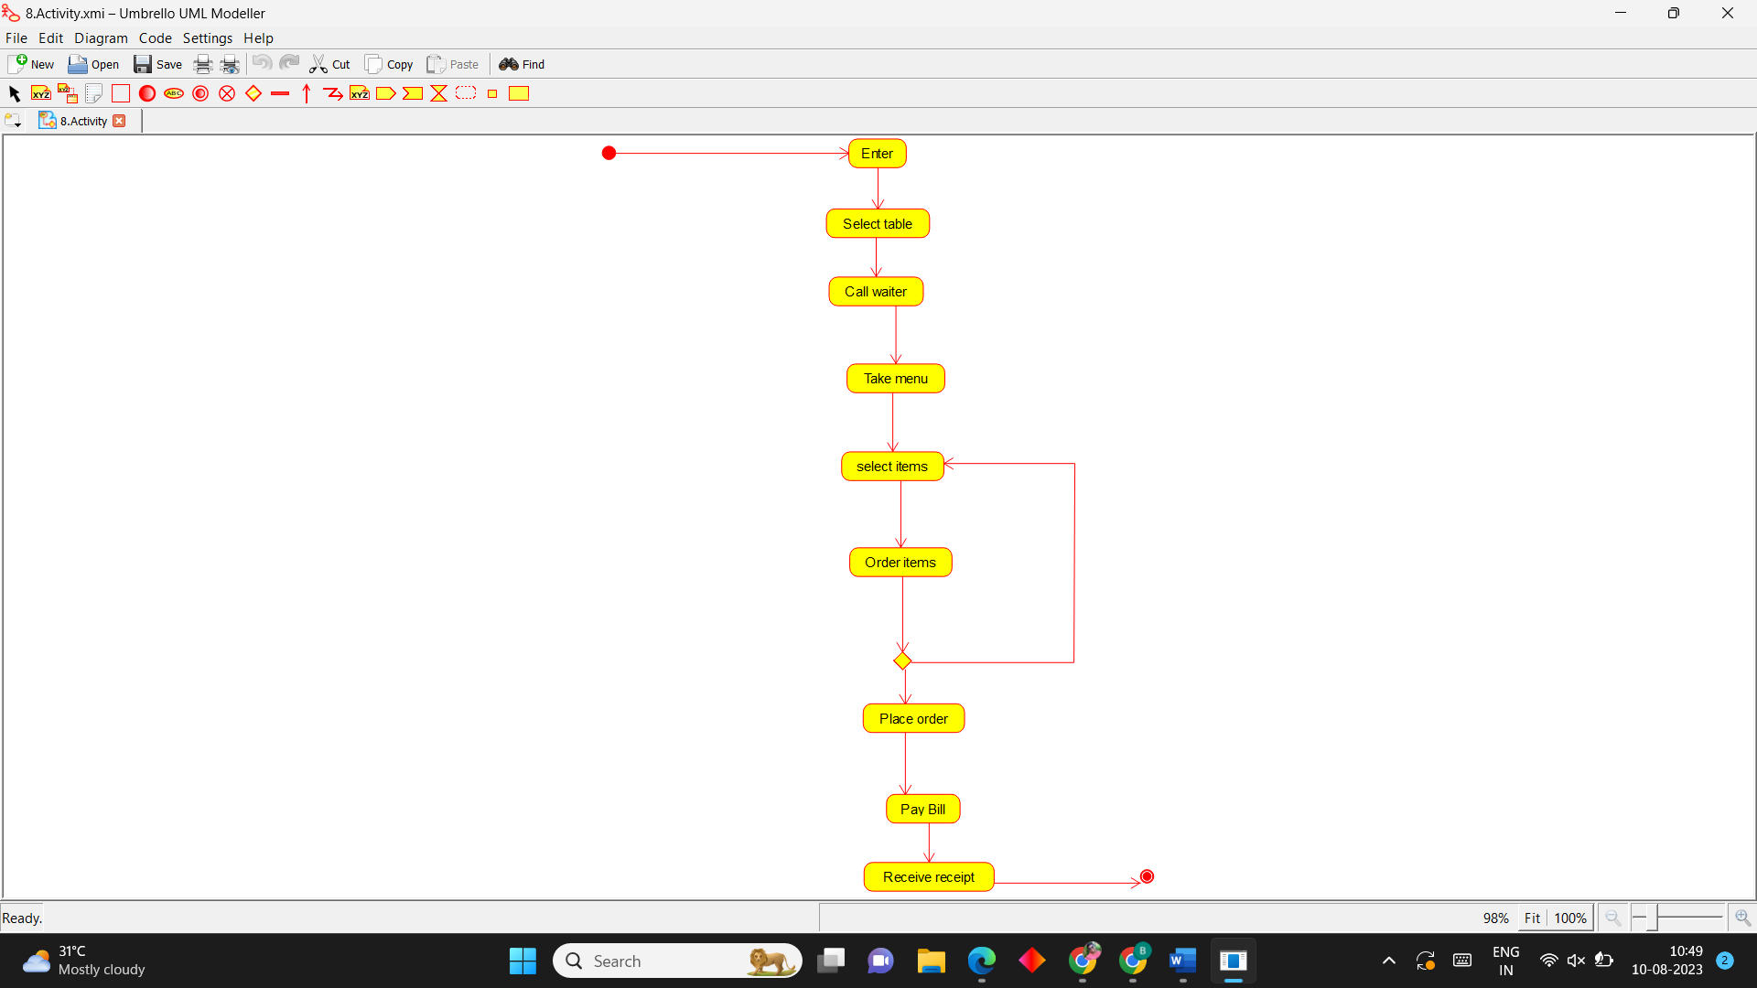

**Sequence Diagram**

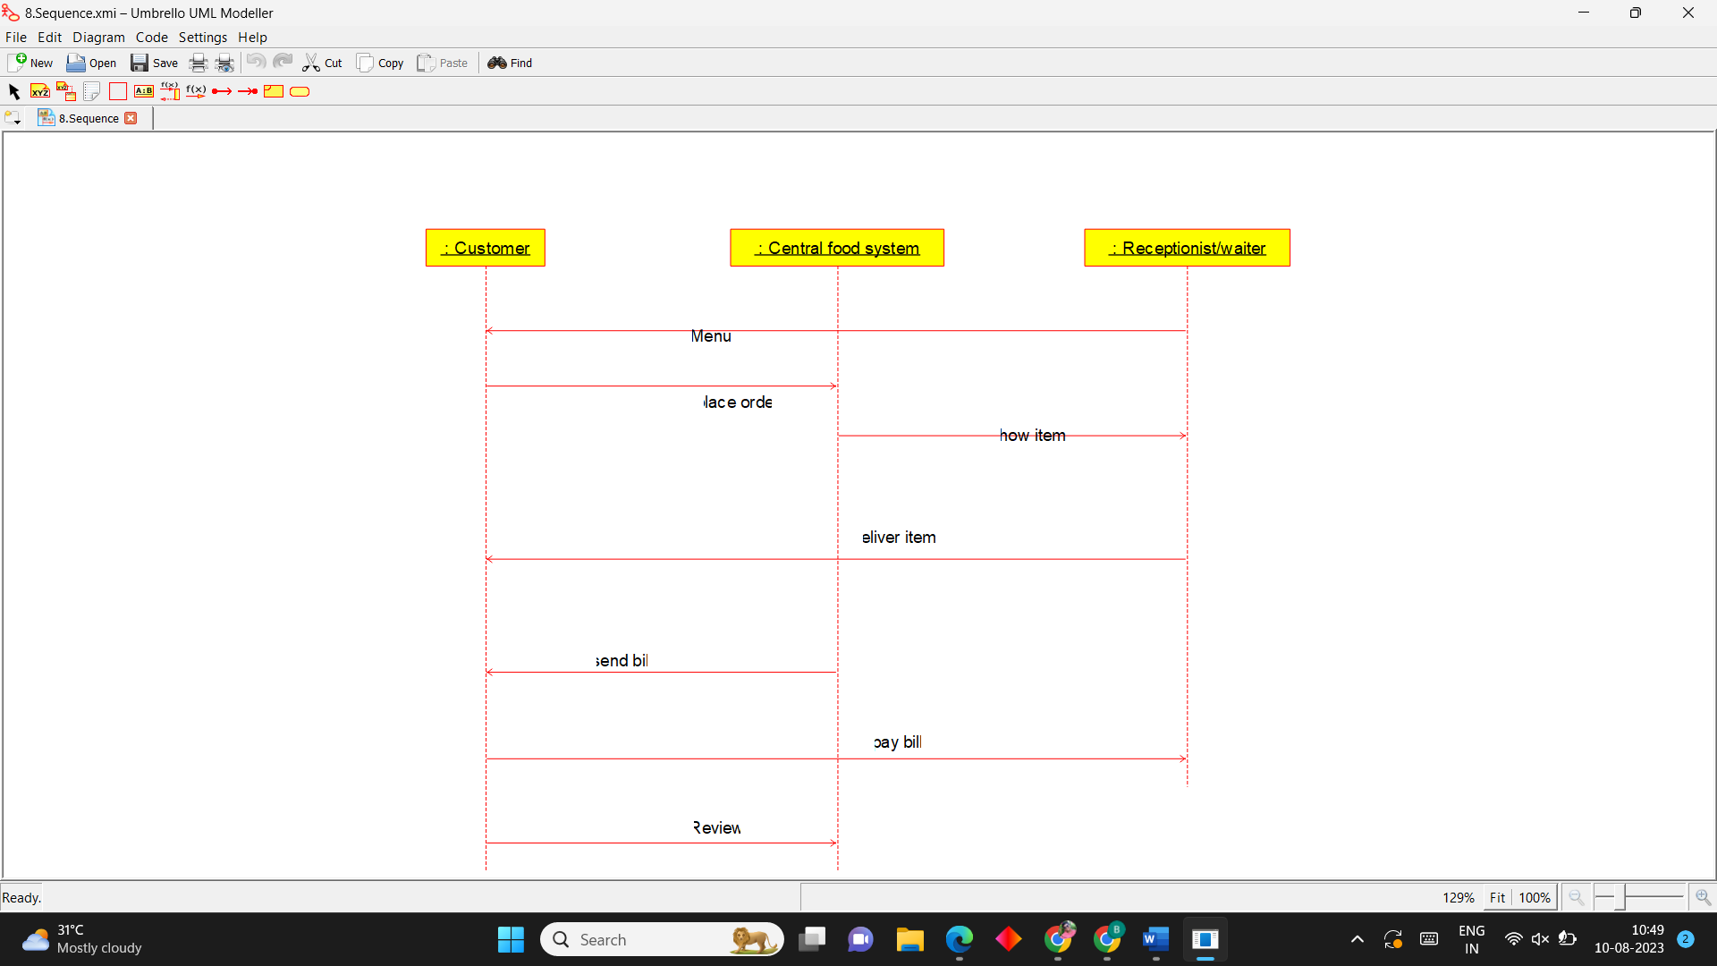

**Class Diagram**

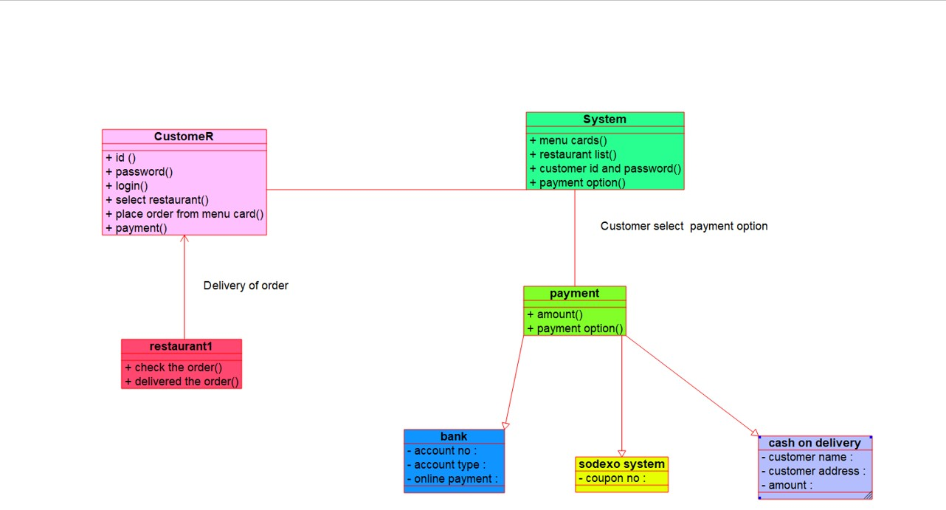

**colloboration Diagram**

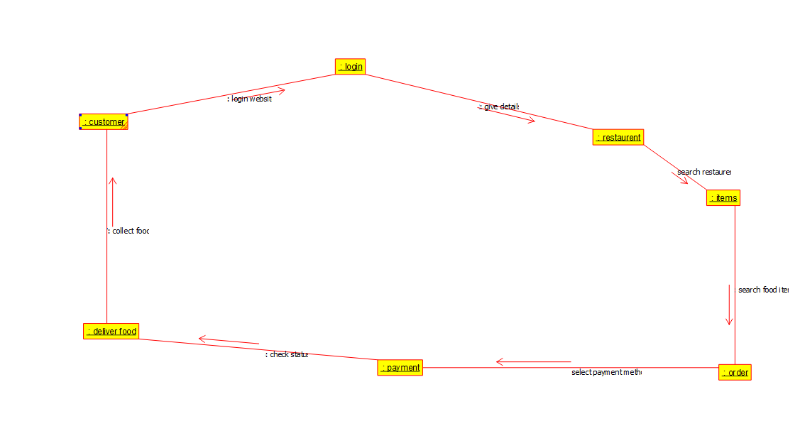

**4.Library Management System**

**Use Case Diagram**

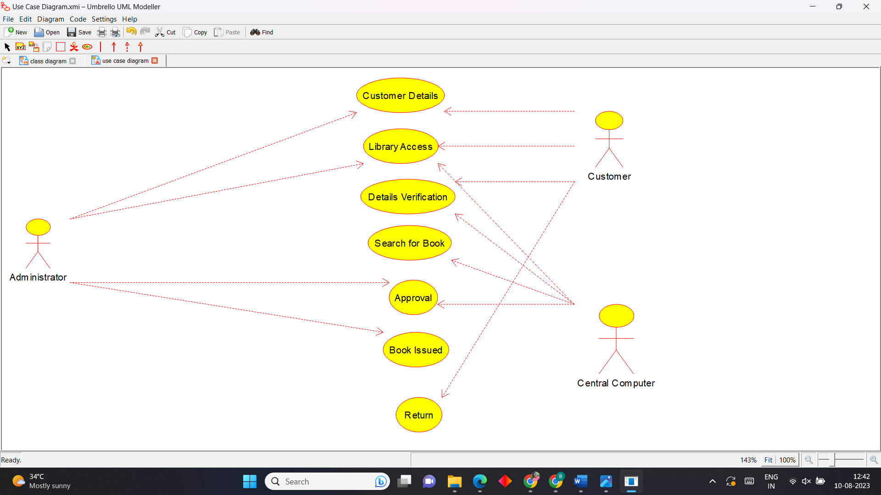

**Activity Diagram**

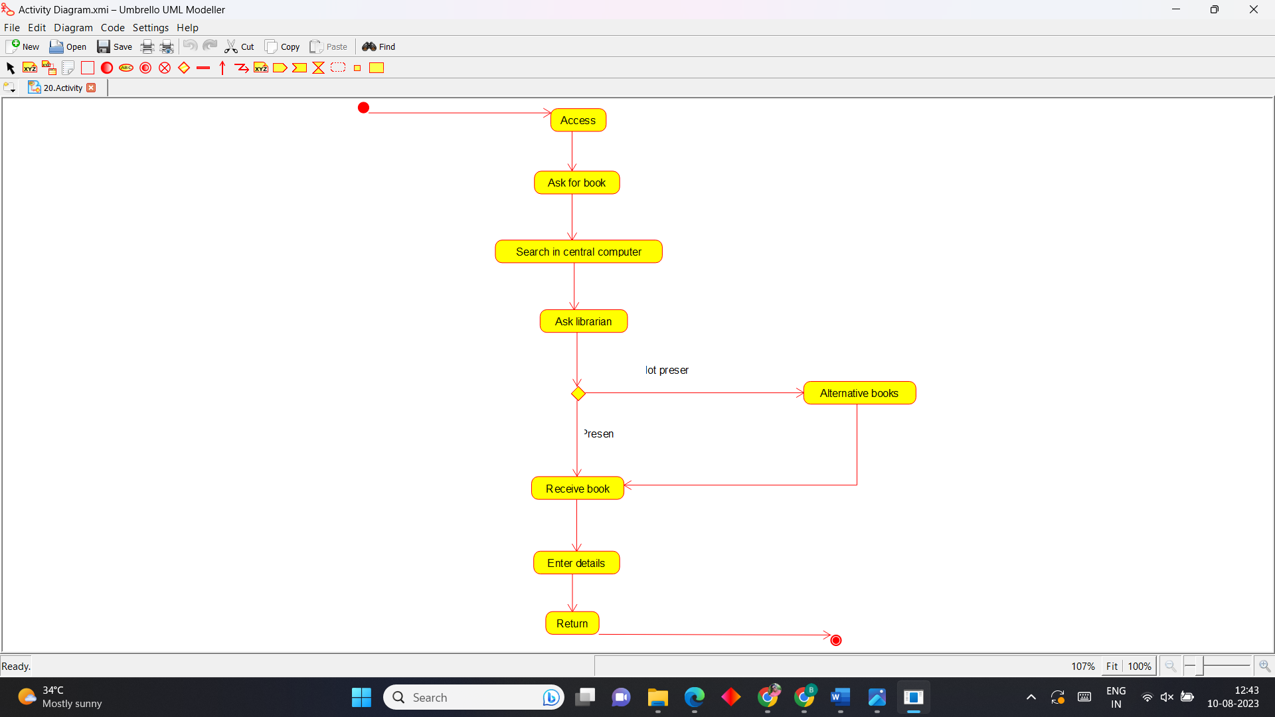

**Sequence Diagram**

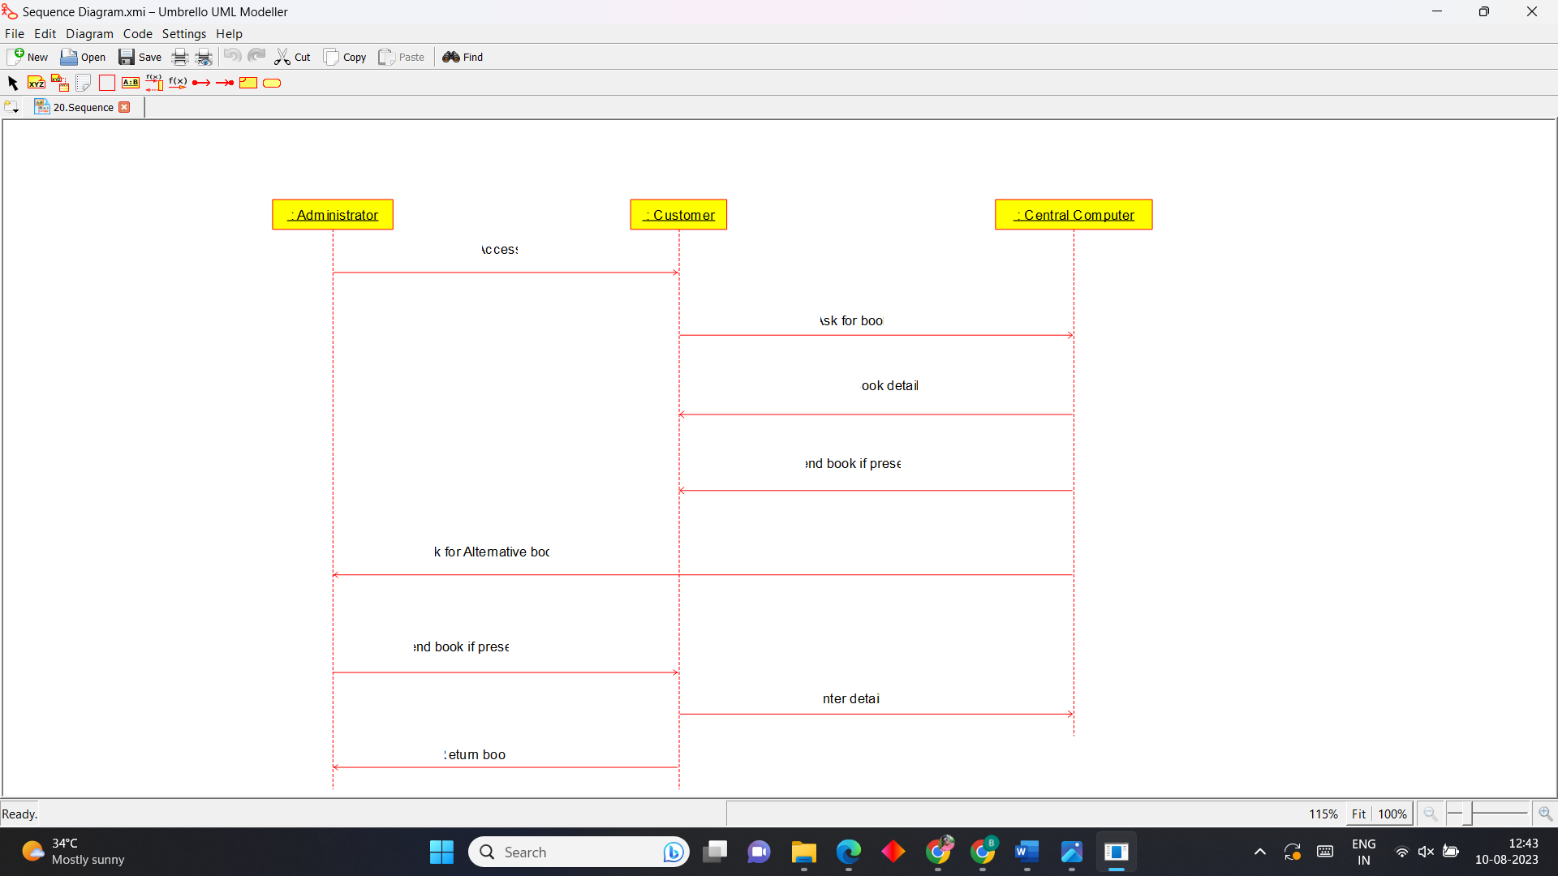

**Package Diagram**

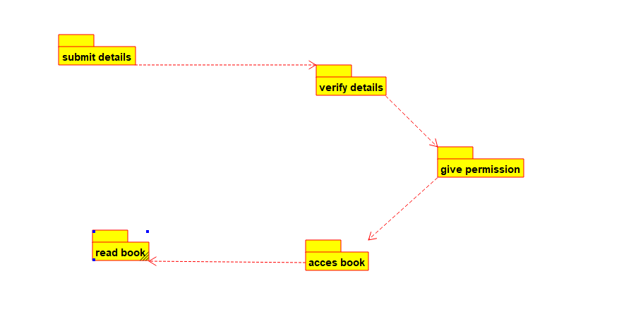

**Component Diagram**

